MDIWindowManager
Copyright © 2006 Carlos Moya

Overview
MDIWindowManager is a control that allows you to create “MDI” applications using a modern Tabbed Document Interface (TDI). The control works on traditional MDI forms and does not require that children be derived from some proprietary base class or implement some special interface or framework. Basically, the control can be dropped on an existing MDI window with no changes at all.
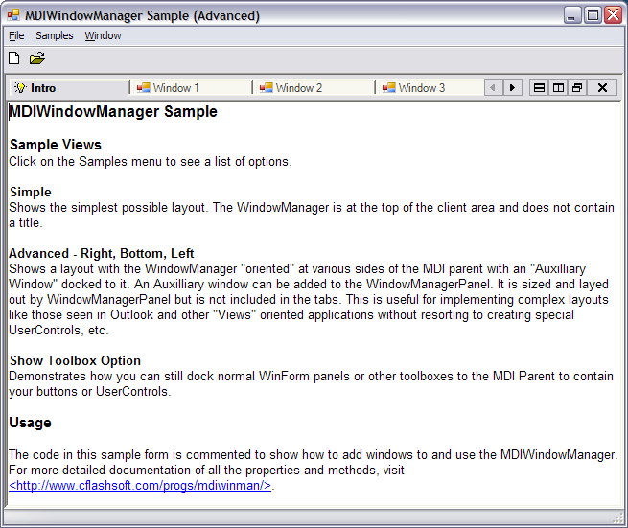
Figure 1 – MDIWindowManager Screenshot (click to see larger image)

More Screen Shots

Usage
Using MDIWindowManager is extraordinarily easy. Simply drop MDIWindowManagerPanel onto any MDI form. You do not need to modify your forms in any way. By default, MDIWindowManager takes care of everything automatically. With the AutoDetectMdiChildWindows property not even your childform loading code needs to be modified.
Dim frm As New ChildForm
frm.MdiParent = Me
'The following is not needed if AutoDetectMdiChildWindows is On
'WindowManagerPanel1.AddWindow(frm)
frm.Show()

Code 1 Usage Example

Appearance
WindowManagerPanel supports several tab styles. You can also set the EnableTabPaintEvent property and complement or completely replace the drawing of tabs in the TabPaint event. Additionally, there is an extensible framework where you can create your own tab providers easily. MDIWindowManager comes with an additional tabs provider called SystemTabsProvider that uses the intrinsic Windows/.NET TabControl.
For more properties and object model see the More Information section elsewhere in this document.

Behind-the-scenes
MDIWindowManager does not do anything particularly special to the MDI child windows. The windows remain regular MDI child windows, but their border is set to none and their size, positioning, and z-order is controlled by MDIWindowManager.

Primary Objects

1) WindowManagerPanel Control
This is the main control that handles all window management. Multiple panels are created automatically to accomplish horizontal tiling (see Layout Details elsewhere in this document).

1.1) WindowTabStrip
A WindowManagerPanel can contain multiple tab strips. Each tab strip can contain a number of MDI children but display only one at a time. Multiple tab strips are used to achieve vertical tiling of windows.

1.2) WrappedWindow
When an MDI child is put under the control of MDIWindowManager, it is put under the control of a complimentary “wrapper” class that helps MDIWindowManager receive events and control the look and feel of the child window.

Layout Details

Vertical and Horizontal Tiling
A WindowManagerPanel always contains at least one TabStrip. The TabStrip is what provides window switching and user interaction. Internally, vertical tiling is accomplished via additional TabStrips while horizontal tiling is done via additional temporary WindowManagerPanels.
WindowManagerPanel
TabStrip
WrappedWindows
TabStrip
WrappedWindows
WindowManagerPanel
(…)
Figure 2 – Tiling - Functional Diagram

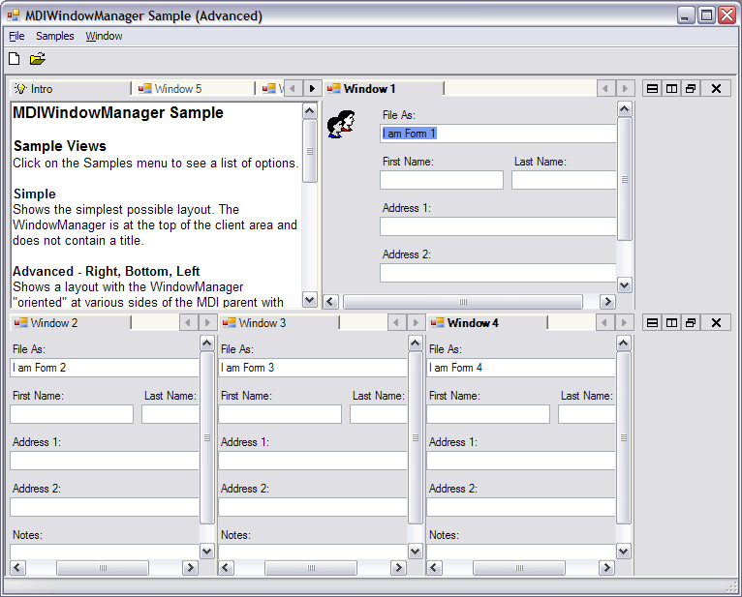
Figure 3 – Real-World Tiling Example

Auxiliary Window
The AuxiliaryWindow property allows you to add an MDI child to MDIWindowManager without having it participate in tab switching but still maintain the TDI aesthetic. The Auxiliary Window is docked to a particular side of WindowManager depending on the WindowManagerPanel’s Orientation property.
You can use the Auxiliary Window property to achieve 2 and 3-pane “Views” like those seen in applications such as MS Outlook.
WindowManagerPanel
TabStrip
WrappedWindows
TabStrip
WrappedWindows
WindowManagerPanel
(…)
Aux Window
Figure 4 – Auxiliary Window Layout with WindowManager Orientation-Right

WindowManagerPanel
TabStrip
WrappedWindows
TabStrip
WrappedWindows
WindowManagerPanel
(…)
Aux Window
Figure 5 – Auxiliary Window Layout with WindowManager Orientation-Bottom

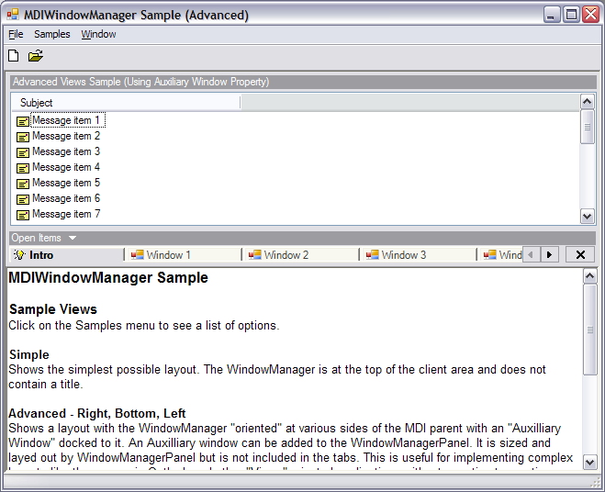
Figure 6 – Real-World Example of Auxiliary Window Use

Important Note: The AuxiliaryWindow simply allows you to treat an MDI child as a “pane” in order to achieve Outlook style 3-pane views without modifying your MDI child or turning it into a UserControl. You can still use Panels and Toolboxes docked to the MDI Parent to house other controls (see More Information).

More Information
Visit http://www.cflashsoft.com/progs/mdiwinman/ for object model documentation and samples.

